SE 3353B – Four-Function Calculator

# State Chart

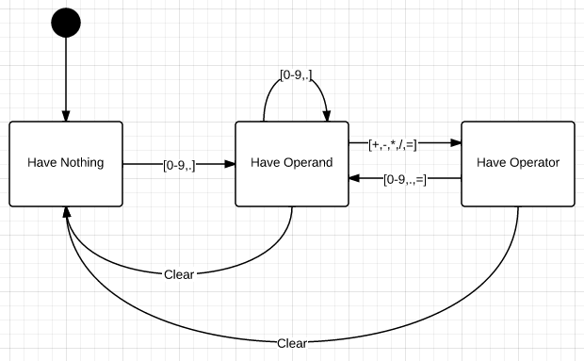

# State Table

|  |  |  |  |
| --- | --- | --- | --- |
| Current\Next | Have Nothing | Have Operand | Have Operator |
| Have Nothing (start) | - | [0-9,.] | - |
| Have Operand | - | [0-9,.] | [+,-,*,/,=] |
| Have Operator | Clear | [0-9,.,=] | - |